**Rahul Surana**

**Assignment Part-3**

**Playing with files**

1. Create a file like nano file1.txt

* Edit some data and then save the file

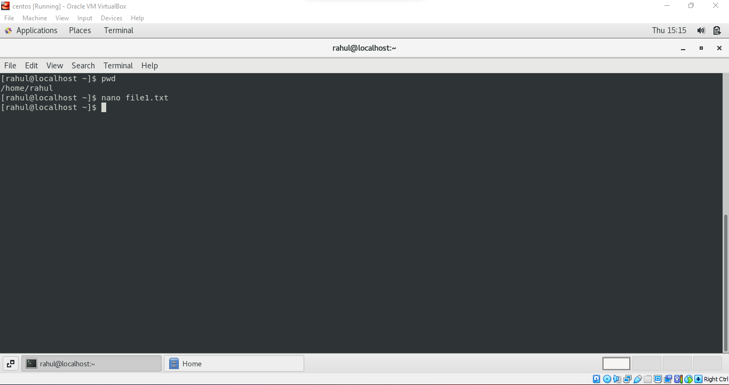

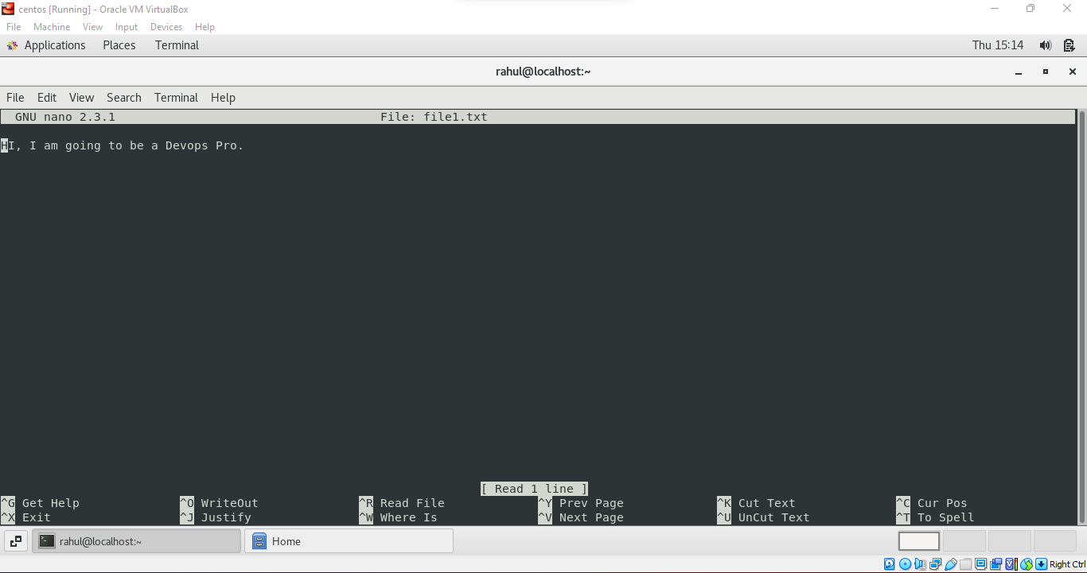

2. Now we will copy date from file1 to new file2

* cp file1.txt file2.txt
* Then see the output of file2.txt, cat file2.txt
* Give screenshot

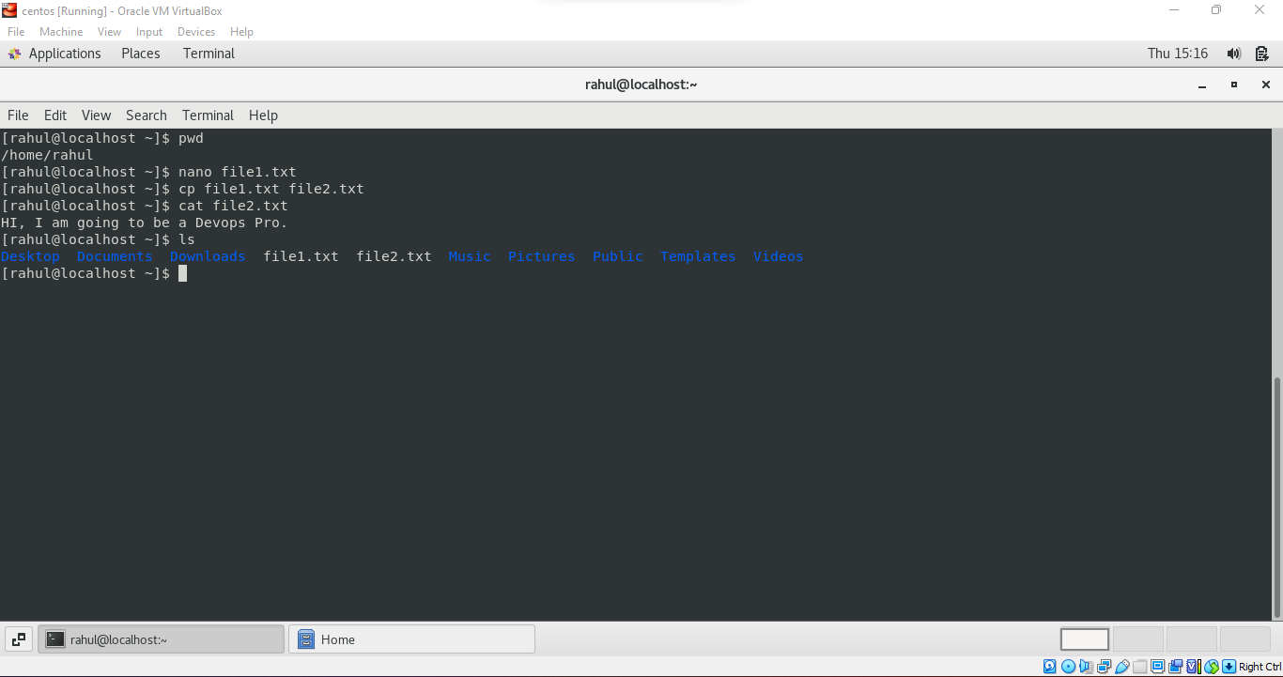

3. Now we will move the file2.txt to new folder /home

* mv file2.txt /home
* Then go to home directory and check ls, file exits or not?
* Given screenshot

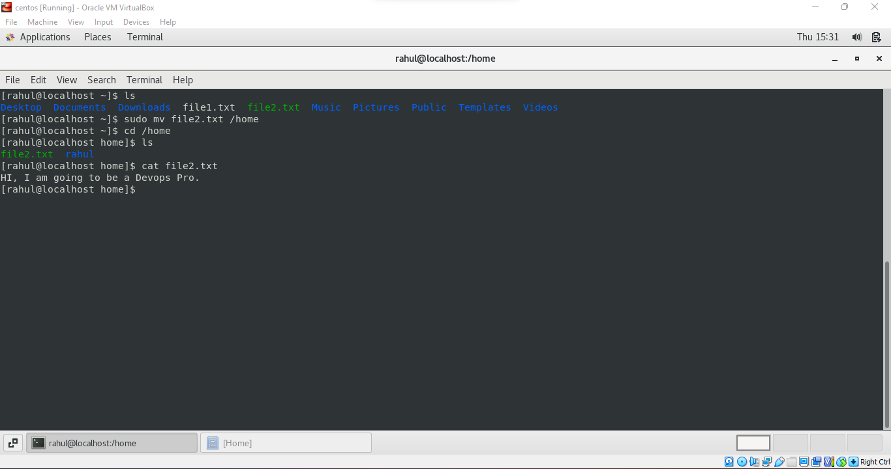

4. Then we create a new file3.txt and file4.txt in home directory and add content in it.

* Now do echo “Hello I am newline” > file3.txt and provide the
* output of file3.txt
* Now do echo “Hello I am newline” >> file4.txt and provide the
* output of file4.txt
* Tell the different between both step you follow and the reason
* behind it

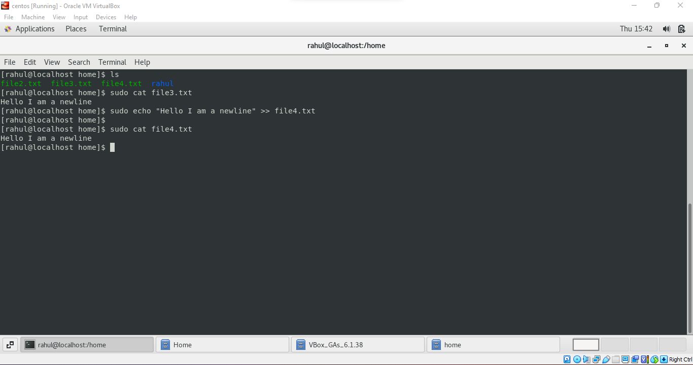

The **“>”** is the output direction operator and it overwrites any existing files, whereas **“>>”** instead of overwriting it appends the data in the file.

5. For remove a file or directory you can use the below two commands

* To delete a file – rm <any_filename>
* To delete a directory – rmdir <any_directorname>

Remove file:

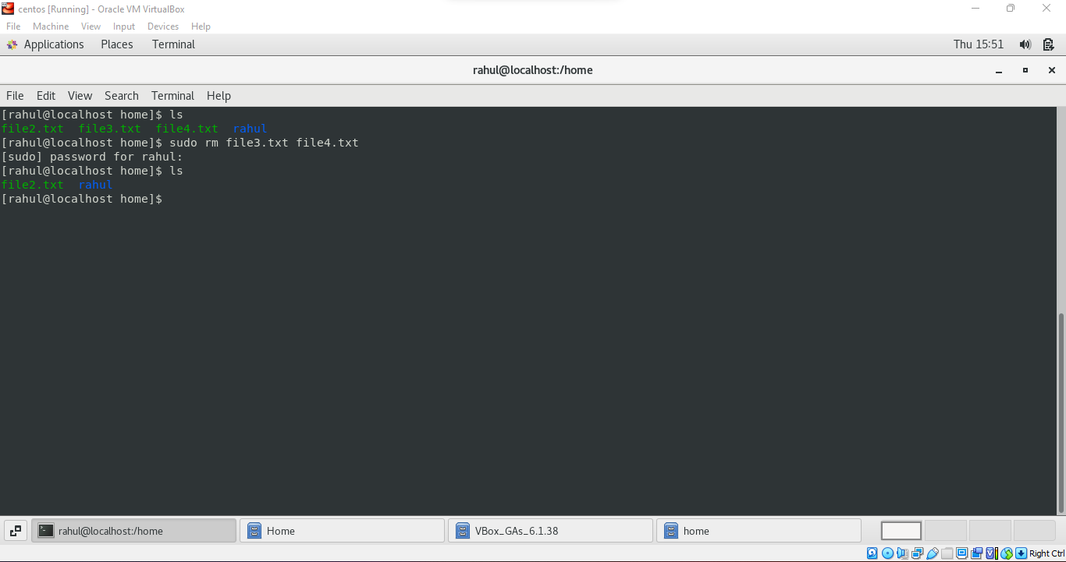

Remove Directory:

